CLASSIC DEVELOPMENTS
Posted in Latest Developments on December 20, 2003
SHARE ARTICLE
ShareTweetShare
I would like to take a moment to publicly endorse something that Anthony Alongi said in his column on Tuesday. The interaction between casual players and the official DCI tournament formats (especially their Banned and Restricted Lists) is a tricky one. Obviously casual players are free to decide for themselves what they want their house rules to be, but a really nice default is to allow decks that are legal in any format. In other words, it's okay to play Chrome Mox in casual play as long as the rest of your deck is legal in Extended (or Standard or whatever other format you like).
I’d like to start my discussion of Type 1 with a story. I went to Gen Con SoCal last weekend to check out the new convention, see what else is going on in the industry, and watch Grand Prix Anaheim. The Con went over quite well for year 1 of a new convention and the Grand Prix was quite interesting, but for me the real highlight of the Con came Saturday night when they auctioned off a case of Arabian Nights…
Arabian Nights was Magic: The Gathering expansion number one. It came out pretty quickly after the game debuted and it was Richard Garfield’s most intensely personal set. The original edition of Magic(“Alpha”) went through a lot of playtesting and many of the playtesters contributed card ideas. Arabian Nights, on the other hand, was all Richard. (You can read more about it by going into the magicthegathering.com archives and looking up everybody’s articles from Arabian Nights week -- including an article from Richard himself.)
At the Gen Con auction Saturday night I got to listen to Wizards of the Coast founder and former CEO Peter Adkison wax nostalgic about the early days of Magic. (Peter was there because he now owns and runs Gen Con.) At the time Wizards produced Arabian Nights, the company operated out of Peter’s basement. When the shipping truck full of Arabian Nights cards showed up at Peter’s house, every employee of the company emerged from the basement and helped unload boxes of product into the company warehouse (better known as Peter’s garage). They all thought they had taken a big chance with Arabian Nights, especially when they decided to print what they thought at the time was a ridiculously large number of cards.
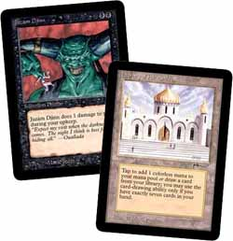Of course, in retrospect we know that demand was much, much higher than what they had supplied. Magic was growing explosively and the set had some amazing cards (like Juzam Djinn and Library of Alexandria) that are staples of competitive Type 1 decks to this day. The combination of all these factors has made cards from the set extremely rare and extremely expensive over the years. Ten years later sealed 8-card booster packs sell for over $100 on the secondary market, and some individual cards from the set fetch over $200.
Anyway, at Gen Con Saturday night an entire case of Arabian Nights slated to be auctioned off. Booster display boxes of Arabian Nights contain 60 booster packs each and when Wizards shipped the product to distributors and stores back in the day they shipped it in “cases” of 10 booster displays. I wasn’t playing Magic back then, so I had never seen even a full booster display of this product before, much less an entire case of it. When I walked over to the case I was blown away by the history I was looking at. Locked behind glass I saw a normal-looking cardboard box with stenciling on it that said “Wizards of the Coast” and “Arabian Nights.” The box still had the original shipping label on it that had been attached to it inside Peter’s garage, along with the original packing tape. The top of the box was open, revealing ten booster displays, each of which was still inside the original shrinkwrap. Wow.
As the time for the auction approached, I watched several dealers scurrying around, trying to figure out how much this item was going to go for. A couple of them got together, figuring it was dumb for them to bid each other up, so they decided to just cooperate to keep the price down and then split it up later. There were 600 booster packs in there, which they knew they’d be able to sell at their stores or websites for at least $110 each, so they figured they could go as high at $60,000 (though they obviously hoped they could get it for less).
The dealers didn’t come close.
Everyone in the room watched in amazement as the bids just kept going higher. $65,000 . . . 70 . . . 75 . . . 80. The auctioneer paused to let everyone gasp and clap. 85 . . . (still two bidders) . . . 90 (still two bidders). “Ninety-five thousand dollars!” . . . Finally one of the two big bidders gave in and that’s what the case went for: $95,000.
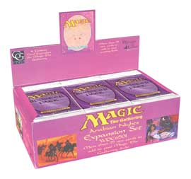The dealers I was hanging out with were incredulous – that price equates to $158.33 per booster pack and they thought the product clearly just wasn’t worth that much. However, I think that analysis misses the point. The two bidders who were going at it at the end were collectors who were trying to purchase a piece of Magichistory. This wasn’t just 600 Arabian Nights booster packs, this was an original shipping container. This had stenciling from Peter Adkison’s garage and tape that was applied by one of Wizards of the Coast’s first employees. This was the piece de resistance for an entire Magic collection – a unique way to display the game’s very first expansion. The cards themselves may have only been worth $60,000, but that cardboard case and all the history it represents was apparently worth another thirty-five.
I think this story is relevant to Type 1 week for a couple of reasons. On the one hand, Type 1 has always been and will always be the format with the closest ties to Magic history. You can’t play serious Type 1 without thinking about those early days when a fledgling game designer and a struggling company put out a game that revolutionized the gaming industry. It took them a while to understand what they had their hands on and many of those early cards are ridiculously overpowered. It’s those ridiculously overpowered cards from the early days before anyone knew how to balance a Magic card that give Type 1 its identity.
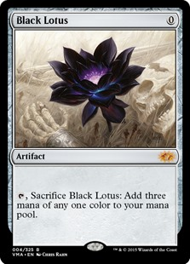
On the other hand, I think this story demonstrates the amazing extent to which Magic has become a collectible. You know you’ve hit the big time when collectors are paying huge sums of money for rare items associated with your game. 1952 Mickey Mantle cards don’t typically go for $95,000, nor does Action Comics #1, and Magic is only 10 years old. Magicsupports a healthy and vibrant community of collectors, and even individual cards like Black Lotus can go for over $1000 in mint condition (and they go a lot higher for “Gem Mint,” especially if they’re Betas). There’s also a market for misprints and oddities (like the Goblin Mob theme deck from the Scourge set that was accidentally printed with card backs from the Harry Potter game -- it went for $13,100 on eBay a few weeks ago. Anyway, my real point with this paragraph is that anyone who tells you that price and collectibility are not important considerations when talking about Type 1 cards is just wrong. Magic cards are a collectible (in addition to being a great game) and we aren’t going to mess that up by reprinting the “Power 9” no matter how many times or how many different ways we’re asked to do it.
On to the discussion of recent Type 1 restrictions that I promised you . . .
Back when I was a professional Magic player, I played my fair share of Type 1. I won the 1999 North American Type 1 championship (the trophy was a piece of plain white paper with the words “North American Type 1 Championship” on it – it’s still around the house somewhere), and placed highly in several other major Type 1 tournaments. For me, Type 1 has always been a nice diversion from regular tournament Magic. It’s fun to feel the raw power of Alpha coursing through your veins again and it’s kind of neat to go for a first-turn kill. Of course, Type 1 isn’t “healthy” in the way we use that term that refer to other formats, and it never can be. When you play with players who have access to all the best cards, many of your opponent’s draws are simply unbeatable, as are many of your own draws. That doesn’t mean interesting things can’t happen, but it does mean the format couldn’t support a Pro Tour (even if the availability of cards wasn’t already problematic enough to prevent us from ever having a Type 1 Pro Tour or qualifier season).
What we can do for Type 1, though, is maintain and update the Banned and Restricted List in an attempt to keep some semblance of balance in the format. We don’t actually ban cards in Type 1 any longer, because the whole point of Type 1 is that it’s the format where you can play every card ever made. However, by restricting all of the most powerful cards we try to make the games stay diverse and interesting. (We also run a Type 1 Championship every summer at Gen Con that is open to all comers.)
A month ago when we were trying to decide whether any cards needed to be added to the Type 1 Restricted List, we put together a copy of “Long.dec” and did some goldfishing. Our version could kill a goldfish on the first turn 60% of the time – an absurdly high percentage of the time, even for Type 1. The public was also complaining about this new deck so we concluded that we clearly needed to do something about it. In addition, we also knew we needed to take a look at the effect of Mirrodin cards on the environment to see if we needed to react to anything.
Long.dec (as posted on StarCity)
Revised List: 8/28/03
By Stephen Menendian
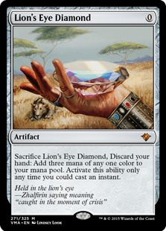
The Mana, a.k.a. 5 Lotuses, 8 Moxes(n), and 5 Rituals, and some land.
3 Chromatic Sphere
4 Lion's Eye Diamond
5 Moxen
1 Lotus Petal
1 Black Lotus
1 Mana Crypt
1 Mana Vault
1 Sol Ring
1 Mox Diamond
4 Dark Ritual
4 Gemstone Mine
4 City of Brass
1 Tolarian Academy
2 Underground Sea
Setting up and protecting the Combo
4 Duress
4 Brainstorm
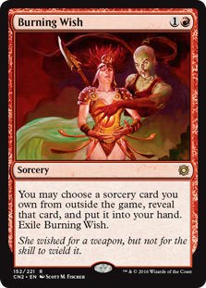
Cards that Fetch cards that win:
4 Burning Wish
1 Ancestral Recall
1 Time Walk
1 Mystical Tutor
1 Vampiric Tutor
1 Demonic Tutor
1 Demonic Consultation
Cards that Win:
1 Timetwister
1 Wheel of Fortune
1 Windfall
1 Tinker
1 Mind's Desire
1 Necropotence
1 Yawgmoth's Bargain
1 Memory Jar
Finisher:
1 Tendrils of Agony
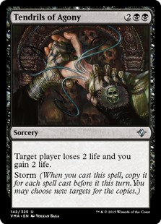
Sideboard:
Finisher:
1 Tendrils of Agony
Engines:
1 Yawgmoth's Will
1 Diminishing Returns
Control Hoser:
4 Xantid Swarm
All Purpose Hoser:
1 Balance
1 Primitive Justice
1 Simplify
1 Hull Breach
1 Regrowth
1 Vindicate
2 Seal of Cleansing
Here’s the current Type 1 Banned and Restricted List. As we announced a couple weeks ago, Burning Wish, Chrome Mox, and Lion’s Eye Diamondare joining this list as of January 1st.
Restricted Cards
Ancestral Recall
Balance
Black Lotus
Black Vise
Braingeyser
Burning Wish
Channel
Chrome Mox
Crop Rotation
Demonic Consultation
Demonic Tutor
Doomsday
Dream Halls
Earthcraft
Enlightened Tutor
Entomb
Fact or Fiction
Fastbond
Fork
Frantic Search
Grim Monolith
Gush
Library of Alexandria
Lion’s Eye Diamond
Lotus Petal
Mana Crypt
Mana Vault
Memory Jar
Mind Over Matter
Mind Twist
Mind's Desire
Mox Diamond
Mox Emerald
Mox Jet
Mox Pearl
Mox Ruby
Mox Sapphire
Mystical Tutor
Necropotence
Regrowth
Sol Ring
Strip Mine
Stroke of Genius
Time Spiral
Time Walk
Timetwister
Tinker
Tolarian Academy
Vampiric Tutor
Voltaic Key
Wheel of Fortune
Windfall
Yawgmoth's Bargain
Yawgmoth's Will

Banned Cards
Amulet of Quoz
Bronze Tablet
Chaos Orb
Contract from Below
Darkpact
Demonic Attorney
Falling Star
Jeweled Bird
Rebirth
Tempest Efreet
Timmerian Fiends

We talked about a number of cards before deciding on our three restrictions (Burning Wish, Chrome Mox, and Lion’s Eye Diamond).
We considered re-restricting Mishra’s Workshop now that Mirrodinhas introduced so many more powerful artifacts into the environment, but eventually decided there just wasn’t enough evidence yet to support putting the Workshop back on the Restricted List. We will definitely be keeping our eyes on Workshop decks in the future.
Bazaar of Baghdad is another old-time land that we put up for debate. It adds a lot of power to the Worldgorger Dragon combo decks that are running around Type 1, but those decks don’t currently seem to be any more degenerate than any of the other decks in the format, so we left well enough alone. Just as we’ll consider restricting the Workshop if artifact decks begin to dominate the format, we’ll consider restricting the Bazaar if the Dragon decks take things over.
We also considered restricting Chalice of the Void. We had heard some complaints that it’s too powerful if one player gets to drop a bunch of Moxes and then drop a Chalice for 0, preventing the other person from using any Moxes at all. We’ve also heard some players claim that the Chalice is actually better in decks with Moxes againstthe “cheap” decks in the format. Players who don’t own the true power cards often play weenie beatdown decks (like Sligh or Stompy) and those decks can be really hurt by a quick Chalice for 1. Toward the end of our discussion, we concluded that Chalice is clearly relevant to what’s going on in Type 1 right now, but it doesn’t sound like anyone has really worked out exactly what that impact is. It’s possible that we’ll need to restrict the Chalice someday, but there’s no good reason to restrict it right now.
The Judgment Wishes made for a pretty interesting conversation. Watching Long.dec in action was a pretty compelling argument for the restriction of Burning Wish. Yawgmoth’s Will is probably the single most powerful effect available in Type 1 (and Balance is probably #2 and you can make a case for Mind Twist as #3). By moving the uber-powerful sorceries into the sideboard, Long.dec is able to run the equivalent of four of them instead of being restricted to just 1. Some versions of the deck even ran Spoils of the Vault to go get Burning Wish and up the effective number of copies of Yawgmoth’s Will in the deck to 8.
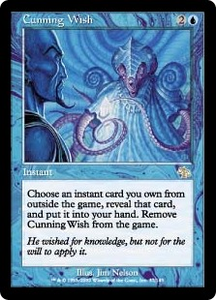
Okay, fair enough, we decided to restrict Burning Wish, but what about Cunning Wish? The cards do pretty much the same thing so they should be treated the same, right? People do play Cunning Wish in Type 1 and they can go get some really powerful cards, but at the end of the day Cunning Wish just isn’t as good as its red cousin. Two crucial differences led us to this conclusion. One is that Cunning Wishcosts an additional mana. The other is that the set of currently available instants just isn’t as good as the sorceries. Sure Ancestral Recall is awesome, but it’s merely undercosted – it’s not an inherently broken effect, whereas Balance and Yawgmoth’s Will do things that are unfair at almost any cost. Cunning Wish is another card that we’ll want to keep an eye on, but I’m honestly not that worried about it right now.
The Burning Wish conversation led us to consider restricting Spoils of the Vault as well. However, we think Spoils of the Vault only looks good when you’re going for a card that you have four copies of in your deck. Even with four copies there’s a big enough chance that you’ll take a suicidal amount of damage that the card doesn’t see a lot of play in Standard or Extended. If you’re going for a restricted card, that chance goes up dramatically so we think that by restricting Burning Wish, Spoils is no longer going to be a problem. It is still a “tutor,” though, so we will of course continue to watch it.
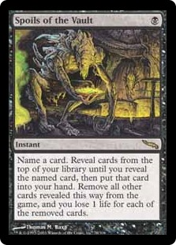
The other two cards that got restricted are both fast mana cards. Lion’s Eye Diamond has been around for years, and it has shown up from time to time in combo decks that have some way to recurse them (usually via Timetwister or Yawgmoth’s Will) and thus use LED mana to pay for lots of spells. Long.dec was the latest of these decks and probably the most efficient at abusing LED, but it was by no means the only one. Cards that provide more mana than they cost are simply too powerful in Type 1, and it doesn’t seem to matter how severe their drawbacks are. That’s the same reason we went ahead and restricted Chrome Mox. Mirrodin hasn’t been out long enough for us to see definitive evidence that the card is definitely a problem, but when it comes to fast mana cards in Type 1, we don’t need to see any more evidence. You should expect us to continue to print fast mana cards with interesting drawbacks (like Chrome Mox) when we think they will be interesting cards in Standard, Extended, and/or casual play; but you should also expect us to immediately restrict them in Type 1.
We talked about a few other cards, but those were the ones that got serious consideration. I hope you enjoyed hearing about the kinds of things we think about as we manage the Type 1 format. In general, I expect Type 1 to maintain its current place in the Magic landscape and I hope people will continue to enjoy it for years and years to come.
Last Week’s Poll:
Have you ever read a Magic novel?
Yes | 5648 | 57.2%
No | 4221 | 42.8%
Total | 9869 | 100.0%
Do you plan to read any Magicnovels in the future?
Yes |  |  | 5425 | 60.8%
No |  |  | 3503 | 39.2%
Total |  |  | 8928 | 100.0%

Which of the following best expresses your opinion about Magicnovels?
I don’t usually read them, but I do like hearing about the story behind the cards | 3701 | 34.9%
I am happy they exist and I sometimes read them | 2349 | 22.1%
I love them and I try to read them all | 1816 | 17.1%
Somebody probably likes them, but that person isn’t me | 1630 | 15.4%
They are an embarrassment to the brand | 947 | 8.9%
I didn’t know they existed | 167 | 1.6%
Total | 10610 | 100.0%
Thanks for the feedback …

Randy may be reached at latestdevelopments@wizards.com.

